**Lab Session 2:**

I refute the argument-> “Security breaches do mostly occur in less-tech-savvy organizations” based on following visuals analysis.

Audience-> I am presenting my visuals to the Security Branch officers of America to explain which organizations have more risk of data loss and what methods are riskier for those organizations so that they can take action specific to those methods and increase security for those organizations.

**Version 1**:

Advantages:  
> I used horizontal bars to analyze security breach according to different organizations.  
> This gave me information about number of records lost by various organizations.   
> At the same time, it could compare records lost in different organizations.

Disadvantages:  
> I could not show method of leaks in this graph.  
> This graph has various data error that could be cleaned for better understanding.  
> Graph does give a clear message as to what is represented and what needs to be concluded of of this visualization.

<https://public.tableau.com/profile/sanjana.thakur#!/vizhome/LabSession2/OrganizationVsRecordLost?publish=yes>

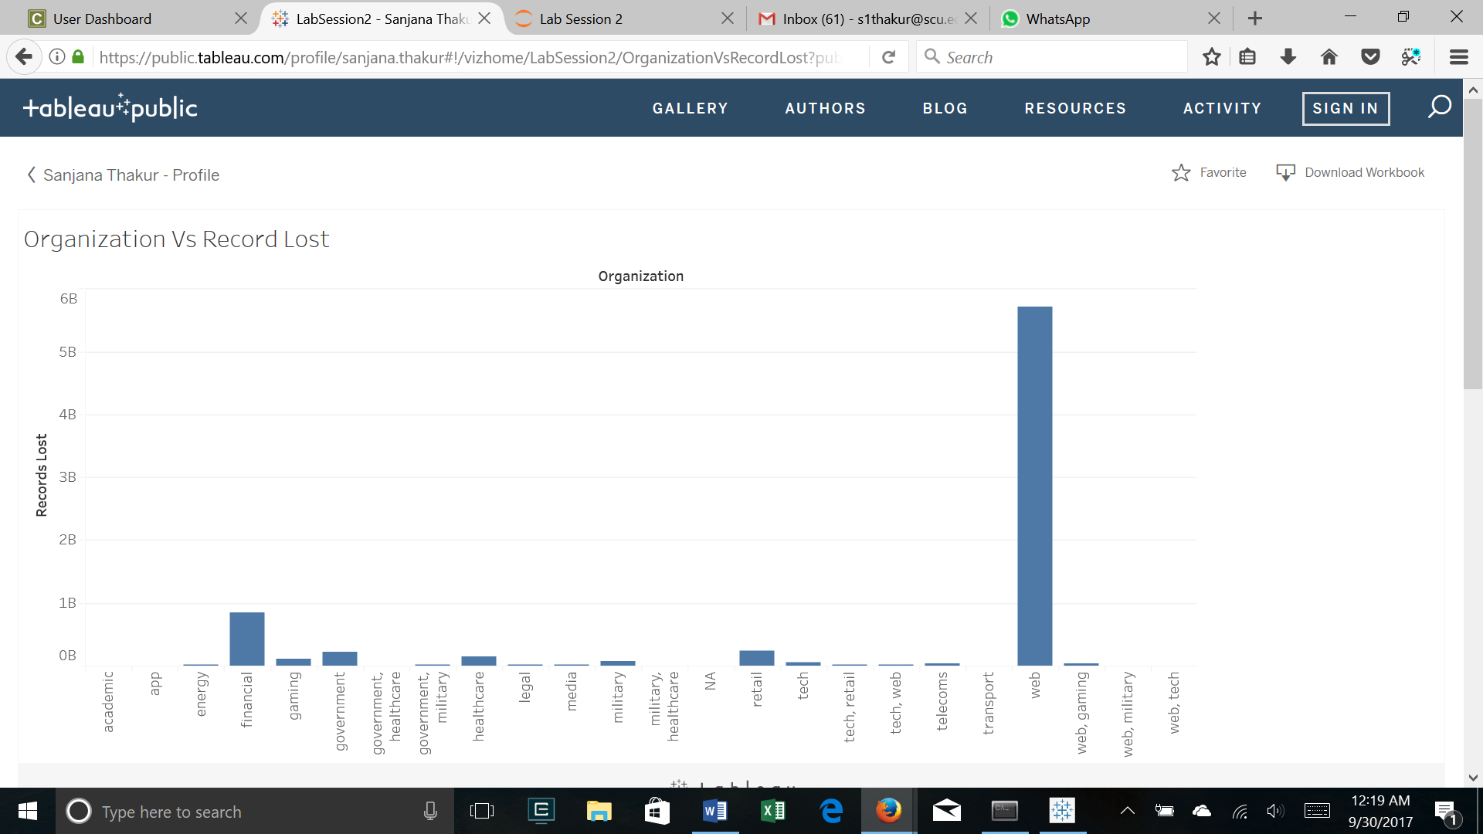

**Version 2**:

Advantages:  
> I improved the shortcoming of previous graph by including “Method of Leak” column.  
> Using stacked bars this time improved the visual showing both organization wise data loss as well as method by which data is lost.

Disadvantages:  
> The meaning of the graph is not clear by the title given.  
> Data errors that could be cleaned for better.  
> Major flaw in this data is that it does not clearly tells which organizations are tech savvy and which ones are not.

<https://public.tableau.com/profile/sanjana.thakur#!/vizhome/Lab_Session_2_2/OrganizationVsRecordsLost?publish=yes>

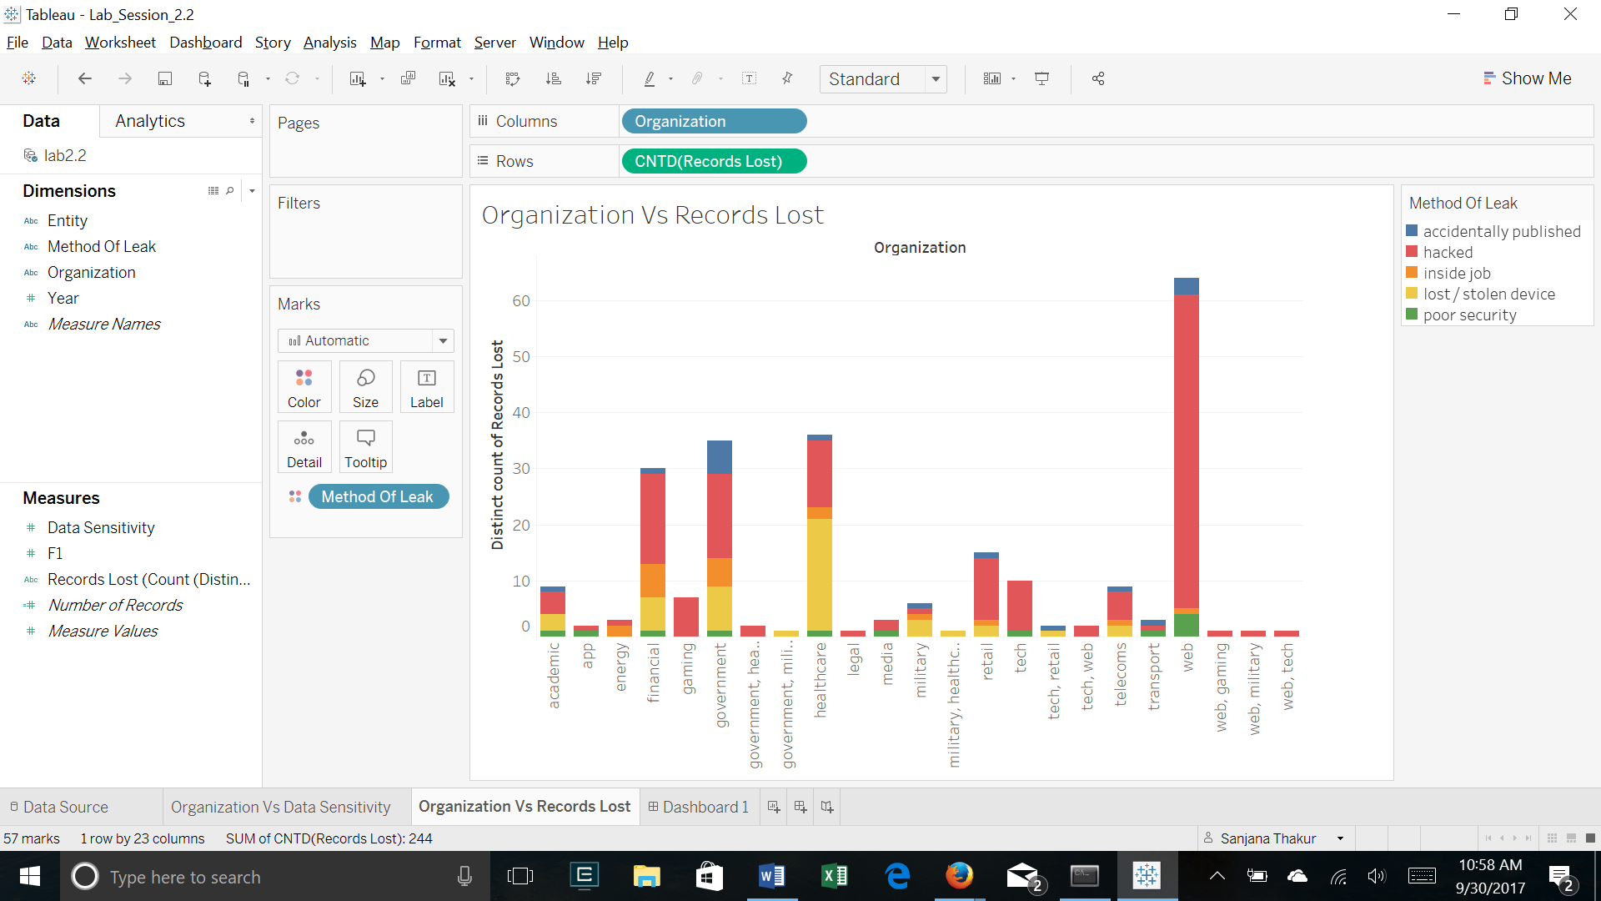

**Version 3**:

Advantages:  
> Changed the title to “Tech Savvy Companies are mostly hacked” to show the objective of the graph.  
> I also used “Treemaps” graph to include Organizational Data Sensitivity. It helps to increase the clarity of audience as to what organizations needs to be protected more when compared with other.  
> I grouped government, military, health, web and tech in “Tech Companies” and the remaining in “Non Tech Companies”. I grouped them on based of mixed factors like data sensitivity and degree of technology usage by the organization.

Disadvantages:  
> I could improve the data to show what kind of data is more sensitive by correcting error in “Data Sensitivity” column.  
> I could include information on graph to show how have I grouped organizations in Tech Vs Non-Tech companies.

<https://public.tableau.com/profile/sanjana.thakur#!/vizhome/Lab_Session_2_3/Dashboard1?publish=yes>

